**PIXEL TO PIXEL IMAGE FUSION USING FPGA(DE10-LITE)**

**GROUP 12**

**SUBMITTED TO**

**Dr. Olawale Akinwale**

**THE DEPARTMENT OF ELECTRONIC AND ELECTRICAL ENGINEERING, FACULTY OF TECHNOLOGY, OBAFEMI AWOLOWO UNIVERSITY, ILE-IFE, OSUN STATE, NIGERIA.**

**JANUARY 2022**

**INTRODUCTION**

With the development of multiple types of biosensors, chemical sensors, and remote sensors on board satellites, more and more data have become available for scientific researches. As the volume of data grows, so does the need to combine data gathered from different sources to extract the most useful information. The term fusion means in general an approach to extraction of information acquired in several domains. The goal of image fusion (IF) is to integrate complementary multisensor, multitemporal and/or multiview information into one new image containing information the quality of which cannot be achieved otherwise. Image fusion has been used in many application areas. In remote sensing and in space exploration, multisensory fusion is used to achieve high spatial and spectral resolutions by combining images from two sensors, one of which has high spatial resolution (large number of dots per inch (dpi)) and the other one high spectral resolution(number and width of spectral bands in a sensor system). Image fusion is defined as a process of combining images, obtained by sensors of different wavelengths simultaneously viewing of the same scene, to form a composite image. The composite image is formed to improve image content, clarity as well as quality.

**TYPES AND METHODS OF IMAGE FUSION**

Types of image fusion Image fusion can be performed roughly at four different stages:

1. Signal level
2. Pixel level
3. Feature level
4. Decision level.

**Signal level fusion**: In signal-based fusion, signals from different sensors are combined to create a new signal with a better signal-to noise ratio than the original signals.

**Pixel level fusion**: Pixel-based fusion is performed on a pixel by-pixel basis. It generates a fused image in which information associated with each pixel is determined from a set of pixels in source images to improve the performance of image processing tasks such as segmentation.

**Feature level fusion**: Feature-based fusion at feature level requires an extraction of objects recognized in the various data sources. It requires the extraction of salient features which are depending on their environment such as pixel intensities, edges or textures. These similar features from input images are fused.

**Decision-level fusion**: It consists of merging information at a higher level of abstraction, combines the results from multiple algorithms to yield a final fused decision. Input images are processed individually for information extraction. The obtained information is then combined applying decision rules to reinforce common interpretation.

**Image Fusion Categorization According to Data Type**: Categorizing the Image fusion methods according to the data entering the fusion and according to the fusion purpose, we distinguish into the following categories.

• Multiview fusion of images from the same modality and taken at the same time but

From different viewpoints.

• Multimodal fusion of images coming from different sensors (visible and infrared, CT and

NMR, or panchromatic and multispectral satellite images).

* Multi-focus fusion of images of a 3D scene taken repeatedly with various focal length. Fusion for image restoration.
* Multitemporal fusion of images taken at different times in order to detect changes between them or to synthesize realistic images of objects which were not photographed in a desired time.

**Image Fusion Approaches**

The process of IF is performed to create a good quality image from each of given images. Image fusion method can be broadly classified into two groups:

1. Spatial domain fusion method

2. Transform domain fusion.

In spatial domain techniques, we directly deal with the image pixels. The pixel values are manipulated to achieve desired result. In frequency domain methods the image is first transferred in to frequency domain. All the fusion operation are performed on the Fourier transform of the image and then the inverse Fourier transform is performed to get the resultant image. The fusion methods like averaging, principal component analysis (PCA) and IHS based methods fall under spatial domain approaches.

Spatial domain approaches produce spatial distortion in fused image but the consequent spatial distortion can be overcome by frequency domain approaches on image fusion. The discrete wavelet transform (DWT) Discrete cosine transform (DCT) pyramid transform, are methods come under transform domain fusion. The highest quality result is obtained by DWT method. The wavelet transform is use to detect local features in a signal process. It also used for decomposition of two dimensional (2D) signals such as 2D gray-scale image signals for multiresolution analysis.

In this project, the method employed, pixel to pixel image fusion is an example of spatial domain fusion because of the direct fusion of the pixels.

**BLOCK DIAGRAM**

The figure below illustrates the block diagram of pixel to pixel-based image fusion.

Start

Read First Image into Matlab

Read Second Image into Matlab

Each Image is converted into its Hexadecimal equivalent

Read the hexadecimal values into the on-board ROM

Hexadecimal values are grouped into 3x3 matrix windows.

Calculate Standard Deviation of Each 3x3 Matrix.

SD of Image1> SD of Image2

Select Image 1

Select Image 2

Selected window is used to form fused image

Fused image is displayed using the FPGA VGA component

fig.1

Stop

The input stage consists of images, of formats like JPG or PNG. but both images should be of same type. These images are taken into system by using MATLAB code platform. Then the hexadecimal form of these images is sent to the FPGA board.

**3*3 image windowing in image processing**

Several algorithms belong to a category called windowing operators. Windowing operators use a window, or neighborhood of pixels, to calculate their output. For example, windowing operator may perform an operation like finding the average of all pixels in the neighborhood of a pixel. In this project, the standard deviation operation is performed on pixel value of 3*3 windows. The pixel around which the window is found is called the origin.

This project is based on the usage of image processing algorithms using these pixel windows to calculate their output. Although a pixel window may be of any size and shape, a square 3x3 size was chosen for this application because it is large enough to work properly and small enough to implement efficiently on hardware. In order to implement a moving window system in VHDL, a design was devised that took advantage of certain features of FPGAs. FPGAs generally handle flip -flops quite easily, but instantiation of memory on chip is more difficult. Still, compared with the other option, off-chip memory, the choice using on-chip memory was clear.

A 3x3 window size was chosen because it was small enough to be easily fit onto the target FPGAs, and is considered large enough to be effective for most commonly used image sizes. With larger window sizes, more FIFOs and flip -flops must be used, which increases the FPGA resources used significantly. Figure 2 below shows a graphic representation of the FIFO and flip -flop architecture used for this design for a given output pixel window.

**Feature extraction and selection of window**

In this project pixel to pixel mapping algorithm is used. It consists of two windows of 3*3, and by using a well-defined algorithm the standard deviation of both windows is calculated. The window which has maximum standard deviation value is considered as window with good contrast. So that 3*3 window is select for final result. Then the fused image is displayed on computer screen. The uploaded project was an unfinished work, I have been unable to get the desired image to be displayed on the Monitor Screen and I hope to be able to complete that and upload a demonstration video.

.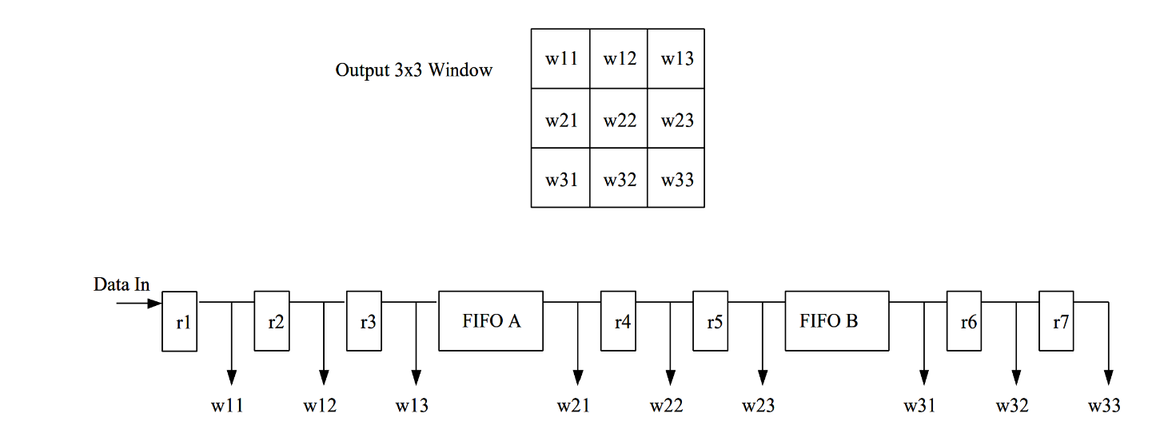

Fig. 2

Architecture of a window generator using FIFOs.

Below is a link to a YouTube video that demonstrates better how this project should work:

<https://youtu.be/nB7l9IO5DSY>